Vacuum Box modifications
  - For the Space-time Optics and Photonics Lab

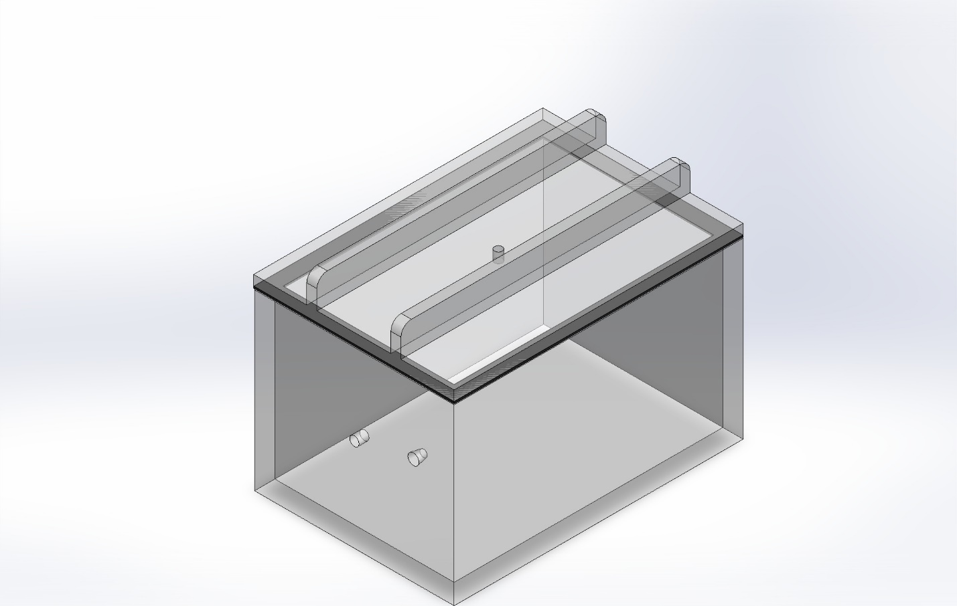
Matthew Krumholz

Top cover modifications:

Increasing hole size:
This top acrylic piece currently has too small of a hole for a vacuum gauge. To fit the vacuum gauge the hole will need to be increased to a diameter of .53 inches, the part measured just a hair over .5 inches. I will include the vacuum gauge, As well as the original acrylic it was in so it can be checked in shop.
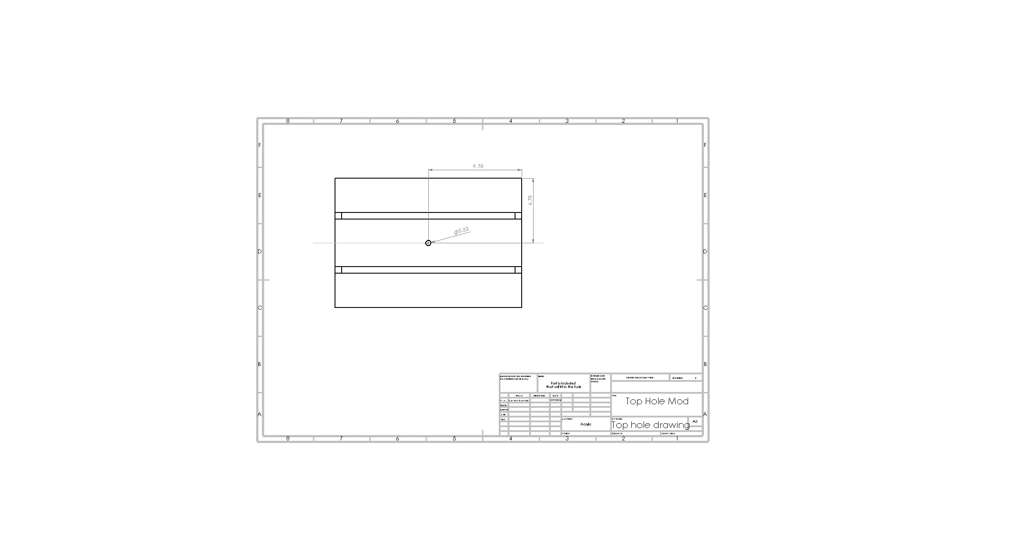

Increasing strength to the top cover:
The top cover tends to bow downward and cause air leakage; to alleviate this issue we want to support it with acrylic strips that will help strengthen it and give the top more support. The vacuum gauge has operating room in this configuration since there is enough room in the middle for the gauge to sit and still be able to operate the ball valves. This was a tough decision since increasing the thickness of the support helped a lot with the simulations but I had to make sure the ball joints will work, there were some tradeoffs. The simulation shows a Dispalcement on the top cover of around .04 of an inch, than the 0.08 inch Displacement without them.
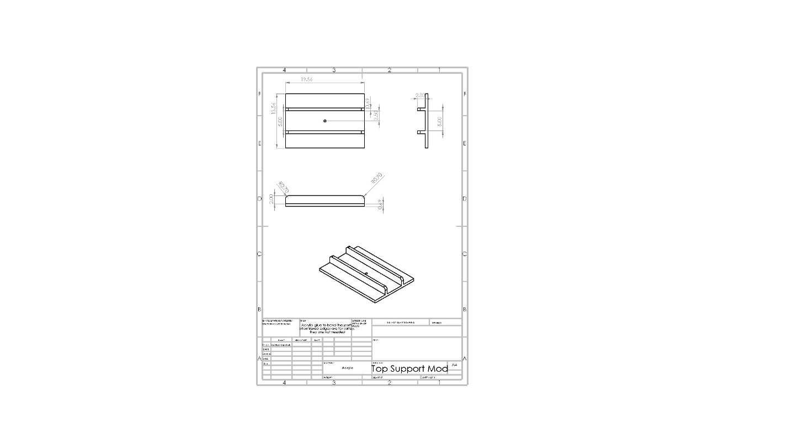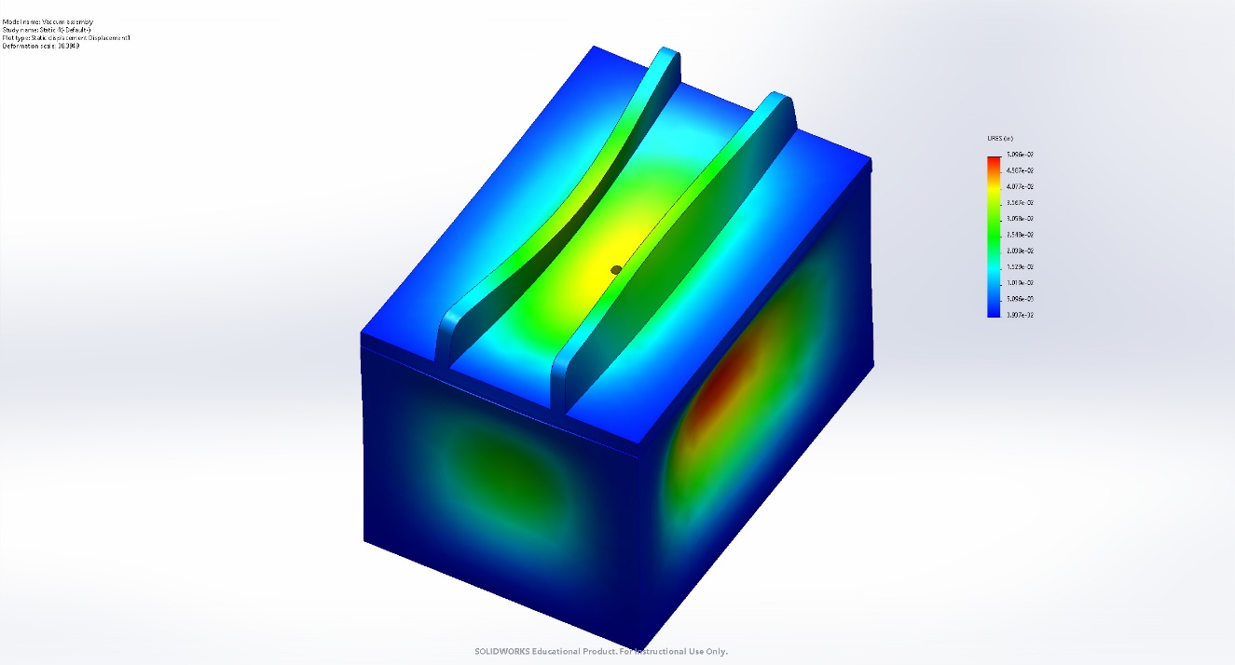

Main Chamber modifications:

Increasing the size of the side hole:
Increasing center entrance size hole to fit a hermetically sealed passthrough. This will increase the 1/8th inch hole to a .630-inch size hole. I will attach the included data sheet that came with the hermetically sealed passthrough. There may be an issue with a shoulder on the hermetically sealed passthrough which may require counter drilling on the exterior of the chamber.
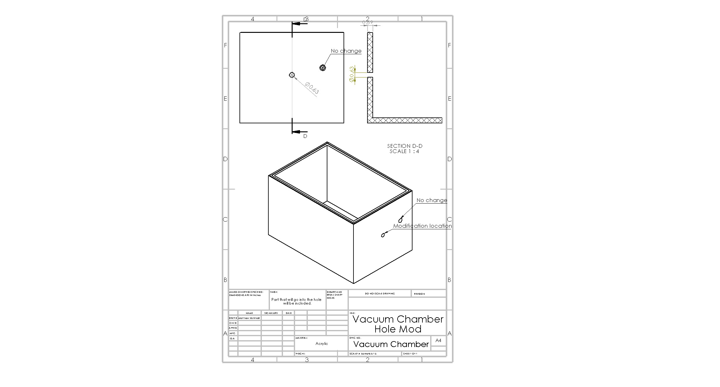
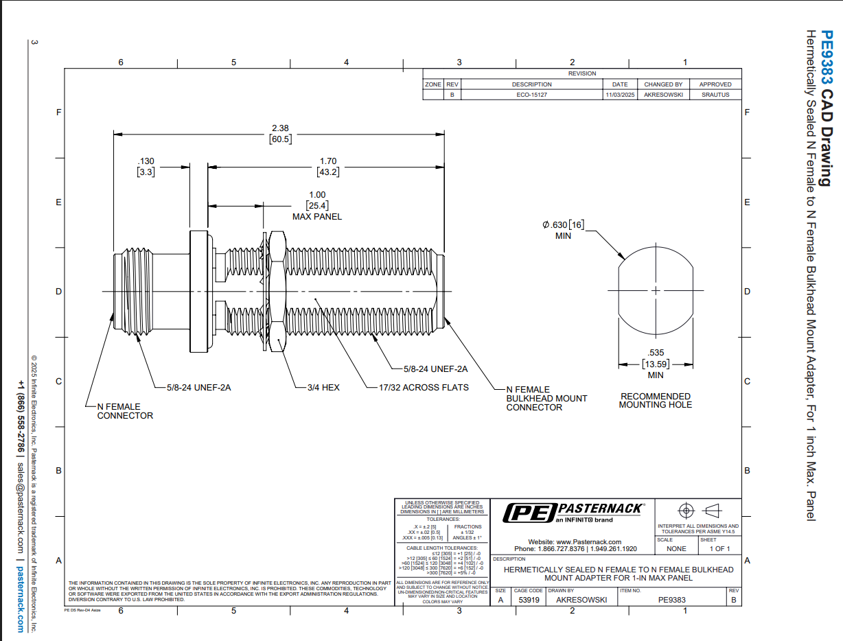

Decreasing the size of the sealing lip:
This modification will take the top of the vacuum box and shave down the outer edge of the current raised edge on the box to create a smaller area and more pressure for a seal to happen. This raised lip will be .25 inches thick, and the inner border that is cut won’t need modifications, it is just the outer border that will need modifications.